XI Lecture: Pathogenic bacteria of Mycobacterium and Actinomyces genera. Pathogenic spirochetes, rickettsia, chlamydia and mycoplasma.

The purpose of the lecture: to provide information about the morpho-biological characteristics of spirochetes, rickettsiae, chlamydia and mycoplasmas, pathogenic factors, pathogenesis of diseases caused by these microorganisms, the main clinical signs, microbiological diagnosis, treatment and prevention.

Lecture plan:
- General characteristics and classification of bacteria of the genus Mycobacterium.
- morpho-biological features, pathogenic factors. Microbiological diagnosis of the disease. BCG vaccine and its importance.
- the causative agent of leprosy. Morpho-biological properties.Microbiological diagnosis. Chemotherapeutic drugs.
- Actinomycetes, morpho-biological properties, microbiological diagnosis of actinomycosis.

- Pathogenic spirochetes. General features, classification.
- Treponemes. The causative agent of syphilis, borrelias, leptospirosis, morpho-biological characteristics, principles of microbiological diagnostics. Specific principles of treatment and prevention.
4. Pathogenic rickettsiae, morpho-biological features.
- The causative agents of rashes (Rickettsia prowazekii, Rickettsia typhi), microbiological diagnosis. Specific principles of treatment and prevention.
- Pathogenic chlamydia, classification, morpho-biological characteristics, diseases caused by different chlamydia.
- Pathogenic mycoplasmas. Classification, morpho-biological characteristics, diseases which causes by mycoplasma . Microbiological diagnosis.
- Ureaplasmas, morpho-biological features, differences from other mycoplasmas. Role in urogenital infections and pregnancy pathology. Microbiological diagnosis. Principles of treatment.

Lecture equipment: Computer, projector, electronic slides.
Literature: p.1

MYCOBACTERIUM
Mycobacteria are aerobic, acid-fast bacilli (rods) .They are neither gram-positive nor gram-negative.They are virtually the only bacteria that are acid-fast. The term acid-fast refers to an organism’s ability to retain the carbolfuchsin stain despite subsequent treatment with an ethanol–hydrochloric acid mixture. The high lipid content of their cell wall makes mycobacteria acid-fast.The major pathogens are Mycobacterium tuberculosis, the cause of tuberculosis, and Mycobacterium leprae, the cause of leprosy.
MYCOBACTERIUM TUBERCULOSIS
Disease
This organism causes tuberculosis. Worldwide, M. tuberculosis causes more deaths than any other single microbial agent. Approximately one-third of the world’s population is infected with this organism. Each year, it is estimated that 1.7 million people die of tuberculosis and that 9 million new cases occur. An estimated 500,000 people are infected with a multidrug-resistant strain of M. tuberculosis.
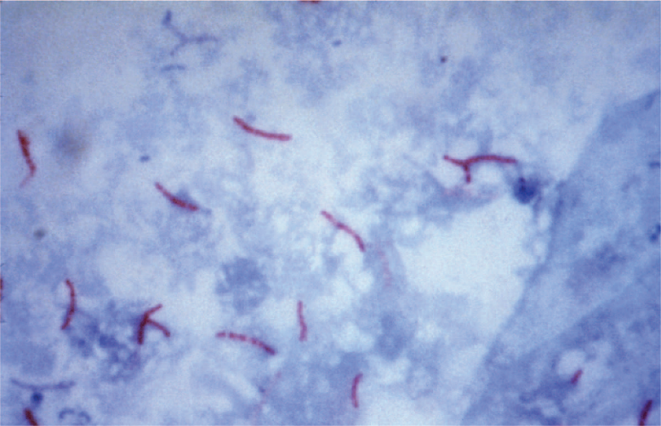
Mycobacterium tuberculosis—acid-fast stain.Long red rods of M. tuberculosis are seen on a blue background

Important Properties
Mycobacterium tuberculosis grows slowly (i.e., it has a doubling time of 18 hours, in contrast to most bacteria, which can double in number in 1 hour or less). Because growth is so slow, cultures of clinical specimens must be held for 6 to 8 weeks before being recorded as negative. Mycobacterium tuberculosis can be cultured on bacteriologic media, whereas M. leprae cannot. Media used for its growth (e.g.,Löwenstein-Jensen medium) contain complex nutrients (e.g., egg yolk) and dyes (e.g., malachite green). The dyes inhibit the unwanted normal flora present in sputum samples. Mycobacterium tuberculosis is an obligate aerobe; this explains its predilection for causing disease in highly oxygenated tissues such as the upper lobe of the lung and the kidney. The acid-fast property of M. tuberculosis (and other mycobacteria) is attributed to long-chain (C78–C90) fatty acids called mycolic acids in the cell wall. Cord factor (trehalose dimycolate) is correlated with virulence of the organism. Virulent strains grow in a characteristic“serpentine” cordlike pattern, whereas avirulent strains do not. The organism also contains several proteins, which, when combined with waxes, elicit delayed hypersensitivity.These proteins are the antigens in the purified protein derivative (PPD) skin test (also known as the tuberculin skin test). A lipid located in the bacterial cell wall called phthiocerol dimycocerosate is required for pathogenesis in the lung. Mycobacterium tuberculosis is relatively resistant to acids and alkalis. NaOH is used to concentrate clinical specimens; it destroys unwanted bacteria, human cells, and mucus but not the organism. M. tuberculosis is resistant to dehydration and therefore survives in dried expectorated sputum; this property may be important in its transmission by aerosol. Strains of M. tuberculosis resistant to the main antimycobacterial drug, isoniazid (isonicotinic acid hydrazide, as well as strains resistant to multiple antibiotics (called multidrug-resistant or MDR strains), have become a worldwide problem. This resistance is attributed to one or more chromosomal mutations, because no plasmids have been found in this organism.
Transmission & Epidemiology
Mycobacterium tuberculosis is transmitted from person to person by respiratory aerosols produced by coughing. The source of the organism is a cavity in the lung that has eroded into a bronchus. The portal of entry is the respiratory tract and the initial site of infection is the lung. In tissue, it resides chiefly within reticuloendothelial cells (e.g., macrophages). Macrophages kill most, but not all, of the infecting organisms. The ones that survive can continue to infect other adjacent cells or can disseminate to other organs. Humans are the natural reservoir of M. tuberculosis. Although some animals, such as cattle, can be infected, they are not the main reservoir for human infection. Most transmission occurs by aerosols generated by the coughing of “smear-positive” people (i.e., those whose sputum contains detectable bacilli in the acid-fast stain). However, about 20% of people are infected by aerosols produced by the coughing of “smear-negative” people. In the United States, tuberculosis is almost exclusively a human disease. In developing countries, Mycobacterium bovis also causes tuberculosis in humans. Mycobacterium bovis is found in cow’s milk, which, unless pasteurized, can cause gastrointestinal tuberculosis in humans. The disease tuberculosis occurs in only a small number of infected individuals. In the United States, most cases of tuberculosis are associated with reactivation in elderly, malnourished men. The risk of infection and disease is highest among socioeconomically disadvantaged people, who have poor housing and poor nutrition.
Pathogenesis
Primary tuberculosis can heal by fibrosis, can lead to progressive lung disease, can cause bacteremia and miliary tuberculosis, or cause hematogenous dissemination resulting in no immediate disease but with the risk of reactivation in later life.Mycobacterium tuberculosis produces no exotoxins and does not contain endotoxin in its cell wall. In fact, no mycobacteria produce toxins. The organism preferentially infects macrophages and other reticuloendothelial cells. Mycobacterium tuberculosis survives and multiplies within a cellular vacuole called a phagosome. The organism produces a protein called “exported repetitive protein” that prevents the phagosome from fusing with the lysosome, thereby allowing the organism to escape the degradative enzymes in the lysosome. Lesions are dependent on the presence of the organism and the host response. There are two types of lesions: (1) Exudative lesions, which consist of an acute inflammatory response and occur chiefly in the lungs at the initial site of infection. (2) Granulomatous lesions, which consist of a central area of giant cells containing tubercle bacilli surrounded by a zone of epithelioid cells. These giant cells, called Langhans’ giant cells, are an important pathologic finding in tuberculous lesions. A tubercle is a granuloma surrounded by fibrous tissue that has undergone central caseation necrosis. Tubercles heal by fibrosis and calcification. The primary lesion of tuberculosis usually occurs in the lungs. The parenchymal exudative lesion and the draining lymph nodes together are called a Ghon complex. Primary lesions usually occur in the lower lobes, whereas reactivation lesions usually occur in the apices. Reactivation lesions also occur in other well-oxygenated sites such as the kidneys, brain, and bone. Reactivation is seen primarily in immunocompromised or debilitated patients. Spread of the organism within the body occurs by two mechanisms: (1) A tubercle can erode into a bronchus, empty its caseous contents, and thereby spread the organism to other parts of the lungs, to the gastrointestinal tract if swallowed, and to other persons if expectorated. (2) It can disseminate via the bloodstream to many internal organs. Dissemination can occur at an early stage if cellmediated immunity fails to contain the initial infection or at a late stage if a person becomes immunocompromised.
Clinical Findings
Clinical findings are protean; many organs can be involved.Fever, fatigue, night sweats, and weight loss are common. The main findings in pulmonary tuberculosis are cough and hemoptysis. Scrofula is mycobacterial cervical lymphadenitis that presents as swollen, nontender lymph nodes, usually unilaterally. Mycobacterium tuberculosis causes most cases of scrofula, but nontuberculous Mycobacteria, such as Mycobacterium scrofulaceum, can also cause scrofula. Lymphadenitis is the most common extrapulmonary manifestation of tuberculosis. Patients infected with human immunodeficiency virus (HIV) are more likely to have multifocal lymphadenitis than those not infected with HIV. Erythema nodosum, characterized by tender nodules along the extensor surfaces of the tibia and ulna, is a manifestation of primary infection seen in patients who are controlling the infection with a potent cell-mediated response. Miliary tuberculosis is characterized by multiple disseminated lesions that resemble millet seeds. Tuberculous meningitis and tuberculous osteomyelitis, especially vertebral osteomyelitis (Pott’s disease), are important disseminated forms. Gastrointestinal tuberculosis is characterized by abdominal pain and diarrhea accompanied by more generalized symptoms of fever and weight loss. Intestinal obstruction or hemorrhage may occur. The ileocecal region is the site most often involved. Tuberculosis of the gastrointestinal tract can be caused by either M. tuberculosis when it is swallowed after being coughed up from a lung lesion or by M. bovis when it is ingested in unpasteurized milk products. Oropharyngeal tuberculosis typically presents as a painless ulcer accompanied by local adenopathy. In renal tuberculosis, dysuria, hematuria, and flank pain occur. “Sterile pyuria” is a characteristic finding. The urine contains white blood cells, but cultures for the common urinary tract bacterial pathogens show no growth. However, mycobacterial cultures are often positive. Note that most (approximately 90%) infections with M. tuberculosis are asymptomatic. Asymptomatic infections, also known as latent infections, can reactivate and cause symptomatic tuberculosis. The most important determinant of whether overt disease occurs is the adequacy of the host’s cell-mediated immune (CMI) response. For example, AIDS patients have a very high rate of reactivation of prior asymptomatic infection and of rapid progression of the disease. In these patients, untreated disease caused by M. tuberculosis has a 50% mortality rate. Furthermore, administration of infliximab (Remicade), a monoclonal antibody that neutralizes tumor necrosis factor (TNF), has activated latent tuberculosis in some patients. Remicade is used in the treatment of rheumatoid arthritis . Diabetics also are predisposed to reactivation and progression of disease.
Laboratory Diagnosis
Acid-fast staining of sputum or other specimens is the usual initial test. Either the Kinyoun version of the acid-fast stain or the older Ziehl-Neelsen version can be used. For rapid screening purposes, auramine stain, which can be visualized by fluorescence microscopy, is used. After digestion of the specimen by treatment with NaOH and concentration by centrifugation, the material is cultured on special media, such as Löwenstein-Jensen agar, for up to 8 weeks. It will not grow on a blood agar plate. In liquid BACTEC medium, radioactive metabolites are present, and growth can be detected by the production of radioactive carbon dioxide in about 2 weeks. A liquid medium is preferred for isolation because the organism grows more rapidly and reliably than it does on agar. If growth in the culture occurs, the organism can be identified by biochemical tests. For example, M. tuberculosis produces niacin, whereas almost no other mycobacteria do. It also produces catalase. Nucleic acid amplification tests can be used to detect the presence of M. tuberculosis directly in clinical specimens such as sputum. Tests are available that detect either the ribosomal RNA or the DNA of the organism. These tests are highly specific, but their sensitivity varies. In sputum specimens that are acid-fast stain positive, the sensitivity is high, but in “smear-negative” sputums, the sensitivity is significantly lower. These tests are quite useful in deciding whether to initiate therapy prior to obtaining the culture results. Because drug resistance, especially to isoniazid (see later), is a problem, susceptibility tests should be performed. However, the organism grows very slowly, and susceptibility tests usually take several weeks, which is too long to guide the initial choice of drugs. To address this problem, molecular tests are available, which detect mutations in the chromosomal genes that encode either the catalase gene that mediates resistance to isoniazid or the RNA polymerase gene that mediates resistance to rifampin. The luciferase assay, which can detect drug-resistant organisms in a few days, is also used. Luciferase is an enzyme isolated from fireflies that produces flashes of light in the presence of adenosine triphosphate (ATP). If the organism isolated from the patient is resistant, it will not be damaged by the drug (i.e., it will make a normal amount of ATP), and the luciferase will produce the normal amount of light. If the organism is sensitive to the drug, less ATP will be made and less light produced.
Treatment & Resistance
Multidrug therapy is used to prevent the emergence of drug-resistant mutants during the long (6- to 9-month) duration of treatment. (Organisms that become resistant to one drug will be inhibited by the other.) Isoniazid (INH), a bactericidal drug, is the mainstay of treatment. Treatment for most patients with pulmonary tuberculosis is with three drugs: INH, rifampin, and pyrazinamide. INH and rifampinare given for 6 months, but pyrazinamide treatment is stopped after 2 months. A somewhat different regimen can also be used. A convenient way to remember that regimen is to give four drugs (isoniazid, rifampin, pyrazinamide, and ethambutol) for 2 months and two drugs (isoniazid and rifampin) for 4 months. In patients who are immunocompromised (e.g., AIDS patients), who have disseminated disease, or who are likely to have INH-resistant organisms, a fourth drug, ethambutol, is added, and all four drugs are given for 9 to 12 months. Although therapy is usually given for months, the patient’s sputum becomes noninfectious within 2 to 3 weeks. The necessity for protracted therapy is attributed to (1) the intracellular location of the organism; (2) caseous material, which blocks penetration by the drug; (3) the slow growth of the organism; and (4) metabolically inactive “persisters” within the lesion. Because metabolically inactive organisms may not be killed by antitubercular drugs, treatment may not eradicate the infection, and reactivation of the disease may occur in the future.
Prevention
The incidence of tuberculosis began to decrease markedly even before the advent of drug therapy in the 1940s. This is attributed to better housing and nutrition, which have improved host resistance. At present, prevention of the spread of the organism depends largely on the prompt identification and adequate treatment of patients who are coughing up the organism. The use of masks and other respiratory isolation procedures to prevent spread to medical personnel is also important. Contact tracing of individuals exposed to patients with active pulmonary disease who are coughing should be done. An important component of prevention is the use of the PPD skin test to detect recent converters and to institute treatment for latent infections as described earlier. Groups that should be screened with the PPD skin test include people with HIV infection, close contacts of patients with active tuberculosis, low-income populations, alcoholics and intravenous drug users, prison inmates, and foreignborn individuals from countries with a high incidence of tuberculosis. Because there are some problems associated with PPD skin tests, such as the measurement and the interpretation of results and the inconvenience of the patient having to return for the skin test to be read, a laboratory test to detect latent infections was developed
Mycobacterium Leprae
Important Properties
Mycobacterium leprae has not been grown in the laboratory, either on artificial media or in cell culture. It can be grown in experimental animals, such as mice and armadillos. Humans are the natural hosts, although the armadillo appears to be a reservoir for human infection in the Mississippi Delta region where these animals are common. In view of this, leprosy can be thought of as a zoonotic disease, at least in certain southern states, such as Louisiana and Texas. The optimal temperature for growth (30°C) is lower than body temperature; therefore, M. leprae grows preferentially in the skin and superficial nerves. It grows very slowly, with a doubling time of 14 days. This makes it the slowest-growing human bacterial pathogen. One consequence of this is that antibiotic therapy must be continued for a long time, usually several years.
Transmission
Infection is acquired by prolonged contact with patients with lepromatous leprosy, who discharge M. leprae in large numbers in nasal secretions and from skin lesions. In the United States, leprosy occurs primarily in Texas, Louisiana, California, and Hawaii. Most cases are found in immigrants from Mexico, the Philippines, Southeast Asia, and India. The disease occurs worldwide, with most cases in the tropical areas of Asia and Africa. The armadillo is unlikely to be an important reservoir because it is not found in many areas of the world where leprosy is endemic.
Pathogenesis
The organism replicates intracellularly, typically within skin histiocytes, endothelial cells, and the Schwann cells of nerves. The nerve damage in leprosy is the result of two processes: damage caused by direct contact with the bacterium and damage caused by CMI attack on the nerves. There are two distinct forms of leprosy—tuberculoid and lepromatous—with several intermediate forms between the two extremes. (1) In tuberculoid (also known as paucibacillary) leprosy, the CMI response to the organism limits its growth, very few acid-fast bacilli are seen, and granulomas containing giant cells form. The nerve damage seems likely to be caused by cell-mediated immunity as there are few organisms and the CMI response is strong. The CMI response consists primarily of CD4-positive cells and a Th-1 profile of cytokines, namely, interferon-γ, interleukin-2, and interleukin-12. It is the CMI response that causes the nerve damage seen in tuberculoid leprosy. The lepromin skin test result is positive. The lepromin skin test is similar to the tuberculin test (see earlier). An extract of M. leprae is injected intradermally, and induration is observed 48 hours later in those in whom a CMI response against the organism exists. (2) In lepromatous (also known as multibacillary) leprosy, the cell-mediated response to the organism is poor, the skin and mucous membrane lesions contain large numbers of organisms, foamy histiocytes rather than granulomas are found, and the lepromin skin test result is negative. The nerve damage seems likely to be caused by direct contact as there are many organisms and the CMI response is poor. There is evidence that people with lepromatous leprosy produce interferon-β (antiviral interferon) in response to M. leprae infection, whereas people with tuberculoid leprosy produce interferon-γ. Interferon-β inhibits the synthesis of interferon-γ thereby reducing the CMI response needed to contain the infection. Note that in lepromatous leprosy, only the cell-mediated response to M. leprae is defective (i.e., the patient is anergic to M. leprae). The cell-mediated response to other organisms is unaffected, and the humoral response to M. leprae is intact. However, these antibodies are not protective. The T-cell response consists primarily of Th-2 cells.
Clinical Findings
The incubation period averages several years, and the onset of the disease is gradual. In tuberculoid leprosy, hypopigmented macular or plaquelike skin lesions, thickened superficial nerves, and significant anesthesia of the skin lesions occur. In lepromatous leprosy, multiple nodular skin lesions occur, resulting in the typical leonine (lionlike) facies (Figure 21–6). After the onset of therapy, patients with lepromatous leprosy often develop erythema nodosum leprosum (ENL), which is interpreted as a sign that cell-mediated immunity is being restored. ENL is characterized by painful nodules, especially along the extensor surfaces of the tibia and ulna, neuritis, and Uveitis. The disfiguring appearance of the disease results from several factors: (1) the skin anesthesia results in burns and other traumas, which often become infected; (2) resorption of bone leads to loss of features such as the nose and fingertips; and (3) infiltration of the skin and nerves leads to thickening and folding of the skin. In most patients with a single skin lesion, the disease resolves spontaneously. Patients with forms of the disease intermediate between tuberculoid and lepromatous can progress to either extreme.

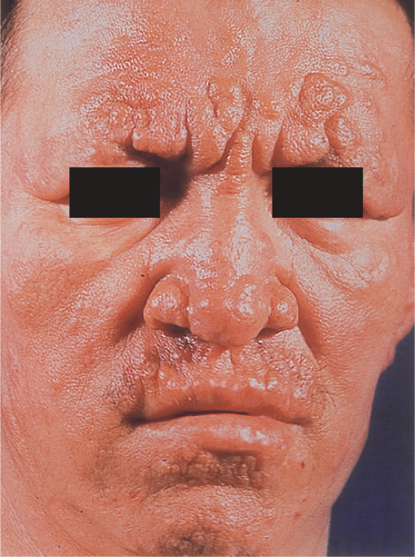
Lepromatous leprosy. The lepromatous form is characterized by multiple, raised lesions, often with the appearance of leonine facies
Laboratory Diagnosis
In lepromatous leprosy, the bacilli are easily demonstrated by performing an acid-fast stain of skin lesions or nasal scrapings. Lipid-laden macrophages called “foam cells” containing many acid-fast bacilli are seen in the skin. In the tuberculoid form, very few organisms are seen, and the appearance of typical granulomas is sufficient for diagnosis. Cultures are negative because the organism does not grow on artificial media. A serologic test for IgM against phenolic glycolipid-1 is useful in the diagnosis of lepromatous leprosy but is not useful in the diagnosis of tuberculoid leprosy. The diagnosis of lepromatous leprosy can be confirmed by using the polymerase chain reaction (PCR) test on a skin sample. False-positive results in the nonspecific serologic tests for syphilis, such as the Venereal Disease Research Laboratory (VDRL) and rapid plasma reagin (RPR) tests, occur frequently in patients with lepromatous leprosy.
Treatment
The mainstay of therapy is dapsone (diaminodiphenylsulfone), but because sufficient resistance to the drug has emerged, combination therapy is now recommended. For tuberculoid (paucibacillary) leprosy, dapsone and rifampin are given for 6 to 12 months whereas for lepromatous (multibacillary) leprosy, a combination of dapsone, rifampin, and clofazimine is given for 12 to 24 months. A combination of ofloxacin plus clarithromycin is an alternative regimen. Thalidomide is the treatment of choice for severe ENL reactions.
Prevention
Isolation of all lepromatous patients, coupled with chemoprophylaxis with dapsone for exposed children, is required. There is no vaccine.

ACTINOMYCETES
Actinomycetes are a family of bacteria that form long, branching filaments that resemble the hyphae of fungi. They are gram-positive, but some (such as Nocardia asteroides) are also weakly acid-fast rods.
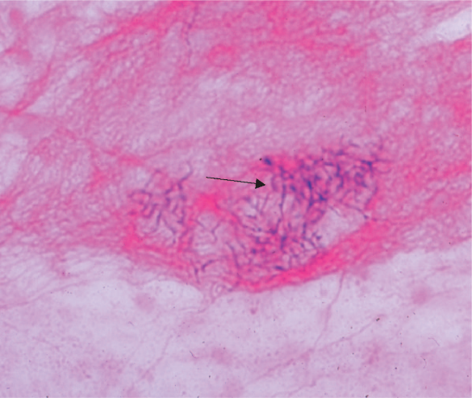
Nocardia asteroides—Gram stain. Arrow points to area of filaments of gram-positive rods.

Actinomyces Israeli
Disease
Actinomyces israelii causes actinomycosis.
Important Properties & Pathogenesis
Actinomyces israelii is an anaerobe that forms part of the normal flora of the oral cavity. After local trauma such as a broken jaw or dental extraction, it may invade tissues, forming filaments surrounded by areas of inflammation.
Clinical Findings
The typical lesion of actinomycosis appears as a hard, nontender swelling that develops slowly and eventually drains pus through sinus tracts. Hard, yellow granules (sulfur granules) composed of a mass of filaments are formed in pus. In about 50% of cases, the initial lesion involves the face and neck; in the rest, the chest or abdomen is the site. Pelvic actinomycosis can occur in women who have retained an intrauterine device for a long period of time. Actinomyces israelii and Arachnia species are the most common causes of actinomycosis in humans. The disease is not communicable.
Laboratory Diagnosis
Diagnosis in the laboratory is made by (1) seeing grampositive branching rods, especially in the presence of sulfur granules; and (2) seeing growth when pus or tissue specimens are cultured under anaerobic conditions. Organisms can be identified by immunofluorescence. Note that in contrast to N. asteroides (see later), Actinomyces is not acid-fast. There are no serologic tests.
Treatment & Prevention
Treatment consists of prolonged administration of penicillin G, coupled with surgical drainage. There is no significant resistance to penicillin G. No vaccine or prophylactic drug is available.
Disease : Nocardia asteroides causes nocardiosis.
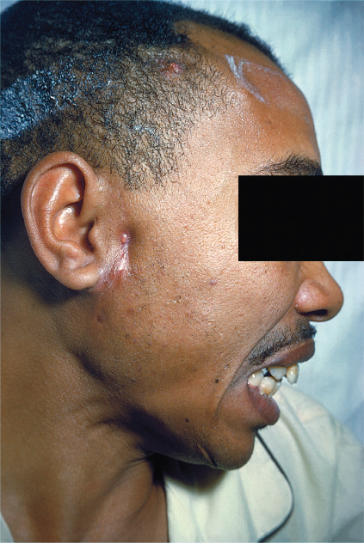
Actinomycosis. Note inflamed lesion with small sinus tract opening anterior to right ear. Yellowish “sulfur granule” can be seen at the opening
Important Properties & Pathogenesis
Nocardia species are aerobes and are found in the environment, particularly in the soil. In immunocompromised individuals, they can produce lung infection and may disseminate. In tissues, Nocardia species are thin, branching filaments that are gram-positive on Gram stain. Many isolates of N. asteroides are weakly acid-fast (i.e., the staining process uses a weaker solution of hydrochloric acid to decolorize than that used in the stain for mycobacteria). If the regular-strength acid is used, N. asteroides will decolorize.
Clinical Findings
Nocardia asteroides typically causes either pneumonia, lung abscess with cavity formation, lung nodules, or empyema. From the lung, the organism can spread to various organs, notably the brain, where it causes brain abscess. Disease occurs most often in immunocompromised individuals, especially those with reduced cell-mediated immunity. Nocardia brasiliensis, a different species of Nocardia, causes skin infections in the southern regions of the United States and mycetoma, usually in tropical regions.
Laboratory Diagnosis
Diagnosis in the laboratory involves (1) seeing branching rods or filaments that are gram-positive or weakly acid-fast in an acid-fast stain and (2) seeing aerobic growth on bacteriologic media in a few days.
Treatment & Prevention
Treatment is with trimethoprim-sulfamethoxazole. Surgical drainage may also be needed. Occasional drug resistance occurs. No vaccine or prophylactic drug is available.

SPIROCHETES
Three genera of spirochetes cause human infection: (1)Treponema, which causes syphilis and the nonvenereal treponematoses; (2) Borrelia, which causes Lyme disease and relapsing fever; and (3) Leptospira, which causes leptospirosis. Spirochetes are thin-walled, flexible, spiral rods. They are motile through the undulation of axial filaments that lie under the outer sheath. Treponemes and leptospirae are so thin that they are seen only by dark field microscopy, silver impregnation, or immunofluorescence. Borreliae are larger, accept Giemsa and other blood stains, and can be seen in the standard light microscope.
Treponema
1. Treponema pallidum
Treponema pallidum causes syphilis.
Important Properties
Treponema pallidum has not been grown on bacteriologic media or in cell culture. Nonpathogenic treponemes, which are part of the normal flora of human mucous membranes, can be cultured. Treponema pallidum grows very slowly. The medical importance of that fact is that antibiotics must be present at an effective level for several weeks to kill the organisms and cure the disease (see “Treatment” section later). For example, benzathine penicillin is the form of penicillin used to treat primary and secondary syphilis because the penicillin is released very slowly from this depot preparation, and bactericidal concentrations are present for weeks after administration of the antibiotic. The antigens of T. pallidum induce specific antibodies, which can be detected by immunofluorescence or hemagglutination tests in the clinical laboratory. They also induce nonspecific antibodies (reagin),1 which can be detected by the flocculation of lipids (cardiolipin) extracted from normal mammalian tissues (e.g., beef heart). Both specific antitreponemal antibody and nonspecific reagin are used in the serologic diagnosis of syphilis.
Transmission & Epidemiology
Treponema pallidum is transmitted from spirochetecontaining lesions of skin or mucous membranes (e.g.,genitalia, mouth, and anus) of an infected person to other persons by intimate contact. It can also be transmitted from pregnant women to their fetuses. Rarely, blood for transfusions collected during early syphilis is also infectious. Treponema pallidum is a human organism only.There is no animal reservoir.Syphilis occurs worldwide, and its incidence is increasing.Many cases are believed to go unreported, which limits public health efforts. There has been a marked increase in incidence of the disease in men who have sex with men in recent years.
Pathogenesis & Clinical Findings
Treponema pallidum produces no important toxins or enzymes. The organism often infects the endothelium of small blood vessels, causing endarteritis. This occurs during all stages of syphilis but is particularly important in the pathogenesis of the brain and cardiovascular lesions seen in tertiary syphilis. In primary syphilis, the spirochetes multiply at the site of inoculation, and a local, nontender ulcer (chancre) usually forms in 2 to 10 weeks. The ulcer heals spontaneously, but spirochetes spread widely via the bloodstream (bacteremia) to many organs.One to 3 months later, the lesions of secondary syphilis may occur. These often appear as a maculopapular rash, notably on the palms and soles, or as moist papules on skin and mucous membranes (mucous patches). Moist lesions on the genitals are called condylomata lata. These lesions are rich in spirochetes and are highly infectious, but they also heal spontaneously. Patchy alopecia also occurs. Constitutional symptoms of secondary syphilis include low-grade fever, malaise, anorexia, weight loss, headache, myalgias, and generalized lymphadenopathy.Pharyngitis, meningitis, nephritis, and hepatitis may also occur. In some individuals, the symptoms of the primary and secondary stages may not occur, and yet the disease may progress. About one-third of these early (primary and secondary) syphilis cases will “cure” themselves, without treatment.Another third remain latent (i.e., no lesions appear, but positive serologic tests indicate continuing infection). The latent period can be divided into early and late stages. In the early latent period, which can last for 1 or 2 years after the secondary stage, the symptoms of secondary syphilis can reappear and patients can infect others. In the late latent period, which can last for many years, no symptoms occur and patients are not infectious. In the remaining onethird of people, the disease progresses to the tertiary stage. Tertiary syphilis may show granulomas (gummas), especially of skin and bones; central nervous system involvement, also known as neurosyphilis (e.g., tabes, paresis); or cardiovascular lesions (e.g., aortitis, aneurysm of the ascending aorta). In tertiary lesions, treponemes are rarely seen. Treponema pallidum also causes congenital syphilis.The organism is transmitted across the placenta, typically after the third month of pregnancy, and fetal infection can occur. In the infected neonates, skin and bone lesions, such as Hutchinson’s teeth, mulberry molars, saber shins, saddle nose, rhagades, snuffles, and frontal bossing, are common.Other findings, such as hepatosplenomegaly, interstitial keratitis, and eighth nerve deafness, also occur. Fetal infection can also result in stillbirth. Immunity to syphilis is incomplete. Antibodies to the organism are produced but do not stop the progression of the disease. Patients with early syphilis who have been treated can contract syphilis again. Patients with late syphilis are relatively resistant to reinfection.
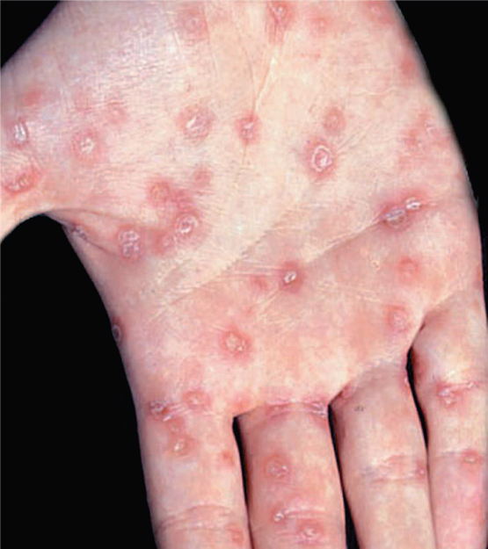
Palmar lesions of secondary syphilis. Note the papulosquamous lesions on the right palm. Palmar lesions are typically Bilateral.
Laboratory Diagnosis
There are three important approaches. Microscopy Spirochetes are demonstrated in the lesions of primary or secondary syphilis, such as chancres or condylomata lata, by dark field microscopy or by direct fluorescent antibody (DFA) test. They are not seen on a Gram-stained smear. In biopsy specimens, such as those obtained from the gummas seen in tertiary syphilis, histologic stains such as silver stain or fluorescent antibody can be used.
Nonspecific Serologic Tests
These tests involve the use of nontreponemal antigens. Extracts of normal mammalian tissues (e.g., cardiolipin from beef heart) react with antibodies in serum samples from patients with syphilis. These antibodies, which are a mixture of IgG and IgM, are called “reagin” antibodies (see earlier). Flocculation tests (e.g., Venereal Disease Research Laboratory [VDRL] and rapid plasma reagin [RPR] tests)detect the presence of these antibodies. These tests are positive in most cases of primary syphilis and are almost always positive in secondary syphilis. The titer of these nonspecific antibodies decreases with effective treatment, in contrast to the specific antibodies, which are positive for life (see later). False-positive reactions occur in infections such as leprosy, hepatitis B, and infectious mononucleosis and in various autoimmune diseases. Therefore, positive results have to be confirmed by specific tests . Results of nonspecific tests usually become negative after treatment and should be used to determine the response to treatment. These tests can also be falsely negative as a result of the prozone phenomenon. In the prozone phenomenon, the titer of antibody is too high (antibody excess), and no flocculation will occur. On dilution of the serum, however, the test result becomes positive. These tests are inexpensive and easy to perform and therefore are used as a method of screening the population for infection.The laboratory diagnosis of congenital syphilis is based on the finding that the infant has a higher titer of antibody in the VDRL test than has the mother. Furthermore, if a positive VDRL test result in the infant is a false-positive one because maternal antibody has crossed the placenta, the titer will decline with time. If the infant is truly infected, the titer will remain high. However, irrespective of the VDRL test results, any infant whose mother has syphilis should be treated.
Specific Serologic Tests
These tests involve the use of treponemal antigens and therefore are more specific than those described earlier. In these tests, T. pallidum reacts in immunofluorescence or hemagglutination (TPHA, MHA-TP)3 assays with specific treponemal antibodies in the patient’s serum. These antibodies arise within 2 to 3 weeks of infection; therefore, the test results are positive in most patients with primary syphilis. These tests remain positive for life after effective treatment and cannot be used to determine the response to treatment or reinfection. They are more expensive and more difficult to perform than the nonspecific tests and therefore are not used as screening procedures.
Treatment
Penicillin G is effective in the treatment of all stages of syphilis. A single injection of benzathine penicillin G (2.4 million units) can eradicate T. pallidum and cure early (primary and secondary) syphilis. Note that benzathine penicillin is used because the penicillin is released very slowly from this depot preparation. Treponema pallidum grows very slowly, which requires that the penicillin be present in bactericidal concentration for weeks. If the patient is allergic to penicillin, doxycycline can be used but must be given for prolonged periods to effect a cure. In neurosyphilis, high doses of aqueous penicillin G are administered because benzathine penicillin penetrates poorly into the central nervous system. No resistance to penicillin has been observed. However, strains resistant to azithromycin have emerged. Pregnant women with syphilis should be treated promptly with the type of penicillin used for the stage of their disease. Neonates with a positive serological test should also be treated. Although it is possible that the positive test is caused by maternal antibody rather than infection of the neonate, it is prudent to treat without waiting several months to determine whether the titer of antibody declines. More than half of patients with secondary syphilis who are treated with penicillin experience fever, chills, myalgias, and other influenzalike symptoms a few hours after receiving the antibiotic. This response, called the Jarisch- Herxheimer reaction, is attributed to the lysis of the treponemes and the release of endotoxin-like substances. Patients should be alerted to this possibility, advised that it may last for up to 24 hours, and told that symptomatic relief can be obtained with aspirin. The Jarisch-Herxheimer reaction also occurs after treatment of other spirochetal diseases such as Lyme disease, leptospirosis, and relapsing fever. Tumor necrosis factor (TNF) is an important mediator of this reaction because passive immunization with antibody against TNF can prevent its symptoms.
Prevention
Prevention depends on early diagnosis and adequate treatment, use of condoms, administration of antibiotic after suspected exposure, and serologic follow-up of infected individuals and their contacts. The presence of any sexually transmitted disease makes testing for syphilis mandatory, because several different infections are often transmitted simultaneously. There is no vaccine against syphilis.
Borrelia
Borrelia species are irregular, loosely coiled spirochetes that stain readily with Giemsa and other stains. They can be cultured in bacteriologic media containing serum or tissue extracts. They are transmitted by arthropods. They cause two major diseases, Lyme disease and relapsing fever.
1. Borrelia burgdorferi
Disease
Borrelia burgdorferi causes Lyme disease (named after a town in Connecticut). Lyme disease is also known as Lyme borreliosis. Lyme disease is the most common tick-borne disease in the United States. It is also the most common vector-borne disease in the United States. Approximately 20,000 cases each year are reported to the Centers for Disease Control and Prevention, and that number is thought to be significantly less than the actual number.
Important Properties
Borrelia burgdorferi is a flexible, motile spirochete that can be visualized by dark field microscopy and by Giemsa and silver stains. It can be grown in certain bacteriologic media, but routine cultures obtained from patients (e.g., blood, spinal fluid) are typically negative. In contrast, culture of the organism from the tick vector is usually positive.
Transmission & Epidemiology
Borrelia burgdorferi is transmitted by tick bite. The tick Ixodes scapularis is the vector on the East Coast and in the Midwest; Ixodes pacificus is involved on the West Coast. The organism is found in a much higher percentage of I. scapularis (35%–50%) than I. pacificus (approximately 2%) ticks. This explains the lower incidence of disease on the West Coast. The main reservoir of the organism consists of small mammals, especially the white-footed mouse, upon which the nymphs feed.4 Large mammals, especially deer, are an obligatory host in the tick’s life cycle but are not an important reservoir of the organism. The nymphal stage of the tick transmits the disease more often than the adult and larval stages do. Nymphs feed primarily in the summer, which accounts for the high incidence of disease during the months of May to September. The tick must feed for 24 to 48 hours to transmit an infectious dose. This implies that inspecting the skin after being exposed can prevent the disease. However, the nymphs are quite small and can easily be missed. There is no human-to-human spread.
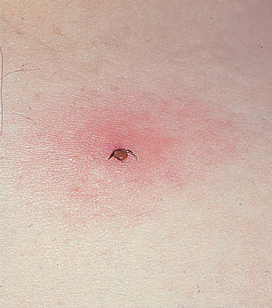
Ixodes tick. Nymph form of tick with head buried in skin surrounded by an erythematous macular rash.
Pathogenesis
Pathogenesis is associated with spread of the organism from the bite site through the surrounding skin followed by dissemination via the blood (bacteremia) to various organs, especially the heart, joints, and central nervous system. No exotoxins, enzymes, or other important virulence factors have been identified. Note that the organism must adapt to two markedly different hosts, the tick and the mammal (either mice or humans). It does so by changing its outer surface protein (OSP). These OSPs vary antigenically within humans. Multiple episodes of Lyme disease are due to reinfection, rather than relapse caused by reactivation of the organism. There is no evidence for a latent stage of B. burgdorferi.
Clinical Findings
The clinical findings have been divided into three stages; however, this is a progressive disease, and the stages are not discrete. In stage 1 (early localized stage), the most common finding is erythema chronicum migrans (also called erythema migrans), an expanding, erythematous, macular rash that often has a “target” or “bull’s eye” appearance.The rash appears between 3 and 30 days after the tick bite. Both the tick bite and the rash are painless and nonpruritic.
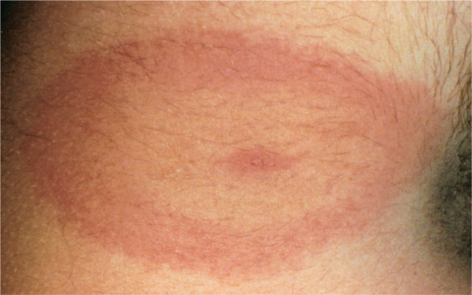
Erythema chronicum migrans rash of Lyme disease. Note oval-shaped expanding erythematous macular “bull’s eye” rash of primary Lyme disease
The rash may sometimes be accompanied by nonspecific “flulike” symptoms such as fever, chills, fatigue, and headache. Secondary skin lesions frequently occur. Arthralgias, but not arthritis, are another common finding in this early stage. In approximately 25% of cases of Lyme disease, no rash is seen. In stage 2 (early disseminated stage), which occurs weeks to months later, cardiac and neurologic involvement predominates. Myocarditis, accompanied by various forms of heart block, occurs. Acute (aseptic) meningitis and cranial neuropathies, such as facial nerve palsy (Bell’s palsy), are prominent during this stage. Bilateral facial nerve palsy is highly suggestive of Lyme disease. Peripheral neuropathies also occur. A latent phase lasting weeks to months typically ensues. In stage 3 (late disseminated stage), arthritis, usually of the large joints (e.g., knees), is a characteristic finding. Lyme arthritis is thought to be autoimmune in origin. Encephalopathy also occurs in stage 3. Some patients treated for Lyme infection continue to have prolonged subjective symptoms of fatigue, joint pains, or mental status changes after objective findings have disappeared. No confirmed microbiologic evidence for B. burgdorferi infection has been detected in those patients, and prolonged antibiotic therapy has not relieved the symptoms.
Laboratory Diagnosis
Although the organism can be grown in the laboratory, cultures are rarely positive and hence are usually not performed. The diagnosis is typically made serologically by detecting either IgM antibody or a rising titer of IgG antibody with an enzyme-linked immunosorbent assay (ELISA) or an indirect immunofluorescence test. IgM is typically detectable 2 weeks after infection and peaks at 3 to 6 weeks. Serologic tests done before 2 weeks are likely to yield negative results. Thirty days after infection, tests for IgG are more reliable. Unfortunately, there are problems with the specificity and sensitivity of these tests because of the presence of cross-reacting antibodies against spirochetes in the normal flora. A positive test result should be confirmed with a Western blot (immunoblot) analysis. In addition, patients treated early in the disease may not develop detectable antibodies. A polymerase chain reaction (PCR) test that detects the organism’s DNA is also available.
Treatment & Prevention
The treatment of choice for stage 1 disease or other mild manifestations is either doxycycline or amoxicillin. Amoxicillin should be used in pregnant women and young children, as doxycycline is contraindicated. For more severe forms or late-stage disease, ceftriaxone is recommended. There is no significant antibiotic resistance. Prevention involves wearing protective clothing and using insect repellents. Examining the skin carefully for ticks is also very important, because the tick must feed for 24 to 48 hours to transmit an infective dose.

Leptospira
Leptospiras are tightly coiled spirochetes with hooked ends. They stain poorly with dyes and so are not seen by light microscopy, but they are seen by dark field microscopy. They grow in bacteriologic media containing serum. Leptospira interrogans is the cause of leptospirosis. Leptospirosis is common in tropical countries, especially in the rainy season, but is rare in the United States. Leptospira interrogans is divided into serogroups that occur in different animals and geographic locations. Each serogroup is subdivided into serovars by the response to agglutination tests. Leptospiras infect various animals, including rats and other rodents, domestic livestock, and household pets. In the United States, dogs are the most important reservoir.Animals excrete leptospiras in urine, which contaminates water and soil. Swimming in contaminated water or consuming contaminated food or drink can result in human infection.Outbreaks have occurred among participants in triathlons and adventure tours involving swimming in contaminated waters. Miners, farmers, and people who work in sewers are at high risk. In the United States, the urban poor have a high rate of infection as determined by the presence of antibodies. Person-to-person transmission is rare. Human infection results when leptospiras are ingested or pass through mucous membranes or skin. They circulate in the blood and multiply in various organs, producing fever and dysfunction of the liver (jaundice), kidneys (uremia), lungs (hemorrhage), and central nervous system (aseptic meningitis). The illness is typically biphasic, with fever, chills, intense headache, and conjunctival suffusion (diffuse reddening of the conjunctivae) appearing early in the disease, followed by a short period of resolution of these symptoms as the organisms are cleared from the blood. The second, “immune,” phase is most often characterized by the findings of aseptic meningitis and, in severe cases, liver damage (jaundice) and impaired kidney function. Serovarspecific immunity develops with infection. Diagnosis is based on history of possible exposure, suggestive clinical signs, and a marked rise in IgM antibody titers. Occasionally, leptospiras are isolated from blood and urine cultures. The treatment of choice is penicillin G. There is no significant antibiotic resistance. Prevention primarily involves avoiding contact with the contaminated environment. Doxycycline is effective in preventing the disease in exposed persons.

RICKETTSIAE
Rickettsiae are obligate intracellular bacteria; that is, they can grow only within cells. They are the agents of several important diseases, namely typhus, spotted fevers such as Rocky Mountain spotted fever, Q fever, anaplasmosis, and ehrlichiosis. Other less important rickettsial diseases such as endemic and scrub typhus occur primarily in developing countries. Rickettsial pox, caused by Rickettsia akari, is a rare disease found in certain densely populated cities in the United States.
RICKETTSIA RICKETTSII &RICKETTSIA PROWAZEKII
Diseases
Rickettsia rickettsii causes Rocky Mountain spotted fever, a life-threatening disease that occurs primarily in the Southeastern states, for example, North Carolina, of the United States. Rickettsia prowazekii causes epidemic typhus, also a life-threatening disease that occurs mainly in crowded, unsanitary living conditions during wartime.
Important Properties
Rickettsiae are very short rods that are barely visible in the light microscope. Structurally, their cell wall resembles that of gram-negative rods, but they stain poorly with the standard Gram stain. Rickettsiae are obligate intracellular parasites, because they are unable to produce sufficient energy to replicate extracellularly. Therefore, rickettsiae must be grown in cell culture, embryonated eggs, or experimental animals. Rickettsiae divide by binary fission within the host cell, in contrast to chlamydiae, which are also obligate intracellular parasites but replicate by a distinctive intracellular cycle.Several rickettsiae, such as R. rickettsii, R. prowazekii,and Rickettsia tsutsugamushi (renamed Orientia tsutsugamushi),possess antigens that cross-react with antigens of the OX strains of Proteus vulgaris. The Weil-Felix test, which detects antirickettsial antibodies in a patient’s serum by agglutination of the Proteus organisms, is based on this cross-reaction.
Transmission
The most striking aspect of the life cycle of the rickettsiae is that they are maintained in nature in certain arthropods such as ticks, lice, fleas, and mites and, with one exception, are transmitted to humans by the bite of the arthropod. The rickettsiae circulate widely in the bloodstream (bacteremia), infecting primarily the endothelium of the blood vessel walls. The exception to arthropod transmission is Coxiella burnetii, the cause of Q fever, which is transmitted by aerosol and inhaled into the lungs. Virtually all rickettsial diseases are zoonoses (i.e., they have an animal reservoir), with the prominent exception of epidemic typhus, which occurs only in humans. It occurs only in humans because the causative organism, R. prowazekii, is transmitted by the human body louse. The incidence of the disease depends on the geographic distribution of the arthropod vector and on the risk of exposure, which is enhanced by such things as poor hygienic conditions and camping in wooded areas. These factors are discussed later with the individual diseases.
Pathogenesis
The typical lesion caused by these rickettsiae is a vasculitis, particularly in the endothelial lining of the vessel wall where the organism is found. Damage to the vessels of the skin results in the characteristic rash and in edema and hemorrhage caused by increased capillary permeability. Vasculitis of the vessels in the brain leads to the prominent headache. The basis for pathogenesis by these organisms is unclear. There is some evidence that endotoxin is involved, which is in accord with the nature of some of the lesions such as fever, petechiae and thrombocytopenia, but its role has not been confirmed. No exotoxins or cytolytic enzymes have been found.
Clinical Findings & Epidemiology
Rocky Mountain Spotted Fever
This disease is characterized by the acute onset of nonspecific symptoms (e.g., fever, severe headache, myalgias, and prostration). The typical rash, which appears 2 to 6 days later, begins with macules that frequently progress to petechiae. The rash usually appears first on the hands and feet and then moves inward to the trunk. In addition to headache, other profound central nervous system changes such as delirium and coma can occur. Disseminated intravascular coagulation, edema, and circulatory collapse may ensue in severe cases. The diagnosis must be made on clinical grounds and therapy started promptly, because the laboratory diagnosis is delayed until a rise in antibody titer can be observed. The name of the disease is misleading, because it occurs primarily along the East Coast of the United States (in the southeastern states of Virginia, North Carolina, and Georgia), where the dog tick, Dermacentor variabilis, is located. The name “Rocky Mountain spotted fever” is derived from the region in which the disease was first found. In the western United States, it is transmitted by the wood tick, Dermacentor andersoni. The tick is an important reservoir of R. rickettsii as well as the vector; the organism is passed by the transovarian route from tick to tick, and a lifetime infection results. Certain mammals, such as dogs and rodents, are also reservoirs of the organism. Humans are accidental hosts and are not required for the perpetuation of the organism in nature; there is no person-to-person transmission. Most cases occur in children during spring and early summer, when the ticks are active. Rocky Mountain spotted fever accounts for 95% of the rickettsial disease in the United States; there are about 1000 cases per year. It can be fatal if untreated, but if it is diagnosed and treated, a prompt cure results.

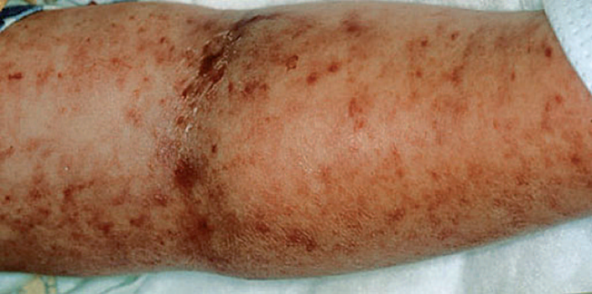
Rocky Mountain spotted fever. Note widespread petechial rash.

Typhus
There are several forms of typhus, namely, louse-borne epidemic typhus caused by R. prowazekii, flea-borne endemic typhus caused by Rickettsia typhi, chigger-borne scrub typhus caused by O. tsutsugamushi, and several other quite rare forms. Cases of flea-borne endemic typhus, also called murine typhus, occur in small numbers in the southern regions of California and Texas. The following description is limited to epidemic typhus, the most important of the typhus group of diseases. Typhus begins with the sudden onset of chills, fever, headache, and other influenzalike symptoms approximately 1 to 3 weeks after the louse bite occurs. Between the fifth and ninth days after the onset of symptoms, a maculopapular rash begins on the trunk and spreads peripherally. The rash becomes petechial and spreads over the entire body but spares the face, palms, and soles. Signs of severe meningoencephalitis, including delirium and coma, begin with the rash and continue into the second and third weeks. In untreated cases, death occurs from peripheral vascular collapse or from bacterial pneumonia. Epidemic typhus is transmitted from person to person by the human body louse, Pediculus. When a bacteremic patient is bitten, the organism is ingested by the louse and multiplies in the gut epithelium. It is excreted in the feces of the louse during the act of biting the next person and autoinoculated by the person while scratching the bite. The infected louse dies after a few weeks, and there is no louse-to-louse transmission; therefore, human infection is an obligatory stage in the cycle. Epidemic typhus is associated with wars and poverty; at present it is found in developing countries in Africa and South America but not in the United States.
Laboratory Diagnosis
Laboratory diagnosis of rickettsial diseases is based on serologic analysis rather than isolation of the organism. Although rickettsiae can be grown in cell culture or embryonated eggs, this is a hazardous procedure that is not available in the standard clinical laboratory. Of the serologic tests, the indirect immunofluorescence and enzyme-linked immunosorbent assay (ELISA) tests are most often used. The Weil-Felix test is of historic interest but is no longer performed because its specificity and sensitivity are too low. A fourfold or greater rise in titer between the acute and convalescent serum samples is the most common way the laboratory diagnosis is made. This is usually a retrospective diagnosis, because the convalescent sample is obtained 2 weeks after the acute sample. If the clinical picture is typical, a single acute-phase titer of 1:128 or greater is accepted as presumptive evidence. If the test is available, a diagnosis can be made during the acute phase of the disease by immunofluorescence assay on tissue obtained from the site of the petechial rash. The Weil-Felix test is based on the cross-reaction of an antigen present in many rickettsiae with the O antigen polysaccharide found in P. vulgaris OX-2, OX-19, and OX-K. The test measures the presence of antirickettsial antibodies in the patient’s serum by their ability to agglutinate Proteus bacteria. The specific rickettsial organism can be identified by the agglutination observed with one or another of these three different strains of P. vulgaris.
Treatment
The treatment of choice for all rickettsial diseases is doxycycline.
Prevention
Prevention of many of these diseases is based on reducing exposure to the arthropod vector by wearing protective clothing and using insect repellent. Frequent examination of the skin for ticks is important in preventing Rocky Mountain spotted fever; the tick must be attached for several hours to transmit the disease. There is no vaccine against Rocky Mountain spotted fever. Prophylactic antibiotics are not recommended in the asymptomatic person bitten by a tick. Prevention of typhus is based on personal hygiene and “delousing” with DDT. A typhus vaccine containing formalinkilled R. prowazekii organisms is effective and useful in the military during wartime but is not available to civilians in the United States.
COXIELLA BURNETII
Disease
Coxiella burnetii causes Q fever. Q stands for “Query”; the cause of this disease was a question mark (i.e., was unknown) when the disease was first described in Australia in 1937.
Important Properties
Coxiella burnetii has a sporelike stage that is highly resistant to drying, which enhances its ability to cause infection. It also has a very low ID50 estimated to be approximately one organism. Coxiella burnetii exists in two phases that differ in their antigenicity and their virulence: phase I organisms are isolated from the patient, are virulent, and synthesize certain surface antigens, whereas phase II organisms are produced by repeated passage in culture, are nonvirulent, and have lost the ability to synthesize certain surface antigens. The clinical importance of phase variation is that patients with chronic Q fever have a much higher antibody titer to phase I antigens than those with acute Q fever.
Transmission
Coxiella burnetii, the cause of Q fever, is transmitted by aerosol and inhaled into the lungs. Q fever is the one rickettsial disease that is not transmitted to humans by the bite of an arthropod. The important reservoirs for human infection are cattle, sheep, and goats. Coxiella burnetii causes an inapparent infection in these reservoir hosts and is found in high concentrations in the urine, feces, placental tissue, and amniotic fluid of the animals. It is transmitted to humans by inhalation of aerosols of these materials.
Clinical Findings & Epidemiology
Unlike other rickettsial diseases, the main organ involved in Q fever is the lungs. It begins suddenly with fever, severe headache, cough, and other influenzalike symptoms. This is all that occurs in many patients, but pneumonia ensues in about half. Hepatitis is frequent enough that the combination of pneumonia and hepatitis should suggest Q fever. A rash is rare, unlike in most of the other rickettsial diseases. In general, Q fever is an acute disease, and recovery is expected even in the absence of antibiotic therapy. Rarely, chronic Q fever characterized by life-threatening endocarditis occurs. The disease occurs worldwide, chiefly in individuals whose occupations expose them to livestock, such as shepherds, abattoir employees, and farm workers. Ingestion of cow’s milk is usually responsible for subclinical infections rather than disease in humans. Pasteurization of milk kills the organism.
Laboratory Diagnosis
Serologic tests, such as the indirect immunofluorescence assay, are used rather than isolation of the organism. Coxiella burnetii can be grown in cell culture or embryonated eggs but this is a hazardous procedure that is not available in the standard clinical laboratory.
Treatment
The treatment of choice is doxycycline.
Prevention
Persons at high risk of contracting Q fever, such as veterinarians, shepherds, abattoir workers, and laboratory personnel exposed to C. burnetii, should receive the vaccine that consists of the killed organism. Pasteurization of milk kills C. burnetii.

CHLAMYDIAE
Chlamydiae are obligate intracellular bacteria (i.e., they can grow only within cells). They are the agents of common sexually transmitted diseases, such as urethritis and cervicitis, as well as other infections, such as pneumonia, psittacosis, trachoma, and lymphogranuloma venereum.
Diseases
Chlamydia trachomatis causes eye (conjunctivitis, trachoma), respiratory (pneumonia), and genital tract (urethritis, lymphogranuloma venereum) infections. Chlamydia trachomatis is the most common bacterial cause of sexually transmitted disease in the United States. Infection with C. trachomatis is also associated with Reiter’s syndrome, an autoimmune disease. Chlamydia pneumoniae causes atypical pneumonia. Chlamydia psittaci causes psittacosis, also a disease characterized mainly by pneumonia s. Chlamydia pneumoniae and C. psittaci are sufficiently different molecularly from C. trachomatis that they have been reclassified into a new genus called Chlamydophila. Taxonomically, they are now Chlamydophila pneumoniae and Chlamydophila psittaci. However, from a medical perspective, they are still known as Chlamydia pneumoniae and Chlamydia psittaci, and those are the names that are used in this book.
Important Properties
Chlamydiae are obligate intracellular bacteria. They lack the ability to produce sufficient energy to grow independently and therefore can grow only inside host cells. They have a rigid cell wall but do not have a typical peptidoglycan layer. Their cell walls resemble those of gram-negative bacteria but lack muramic acid. Chlamydiae have a replicative cycle different from that of all other bacteria. The cycle begins when the extracellular, metabolically inert, “sporelike” elementary body enters the cell and reorganizes into a larger, metabolically active reticulate body. The latter undergoes repeated cycles of binary fission to form daughter reticulate bodies, which then develop into elementary bodies, which are released from the cell. Within cells, the site of replication appears as an inclusion body in the cytoplasm, which can be stained and visualized microscopically.These inclusions are useful in the identification of these organisms in the clinical laboratory. All chlamydiae share a group-specific lipopolysaccharide antigen, which is detected by complement fixation tests. They also possess species-specific and immunotypespecific antigens (proteins), which are detected by immunofluorescence. Chlamydia psittaci and C. pneumoniae each have one immunotype, whereas C. trachomatis has at least 15 immunotypes.
Transmission & Epidemiology
Chlamydia trachomatis infects only humans and is usually transmitted by close personal contact (e.g., sexually or by passage through the birth canal). Individuals with asymptomatic genital tract infections are an important reservoir of infection for others. In trachoma, C. trachomatis is transmitted by finger-to-eye or fomite-to-eye contact. Chlamydia pneumoniae infects only humans and is transmitted from person to person by aerosol. Chlamydia psittaci infects birds (e.g., parrots, pigeons, and poultry, and many mammals including humans). Humans are infected primarily by inhaling organisms in airborne dry bird feces. Sexually transmitted disease caused by C. trachomatis occurs worldwide, but trachoma is most frequently found in developing countries in dry, hot regions such as northern Africa. Trachoma is a leading cause of blindness in those countries. Patients with a sexually transmitted disease are coinfected with both C. trachomatis and Neisseria gonorrhoeae in approximately 10% to 30% of cases.
Pathogenesis & Clinical Findings
Chlamydiae infect primarily epithelial cells of the mucous membranes or the lungs. They rarely cause invasive, disseminated infections.
CHLAMYDIA TRACHOMATIS
Chlamydia trachomatis has more than 15 immunotypes (A–L). Types A, B, and C cause trachoma, a chronic conjunctivitis endemic in Africa and Asia. Trachoma may recur over many years and may lead to blindness but causes no systemic illness. Types D–K cause genital tract infections. In men, it is a common cause of nongonococcal urethritis (often abbreviated NGU), which is characterized by dysuria and a watery, nonpurulent urethral discharge . The discharge may be slight, detectable only by staining of underwear overnight. This infection may progress to epididymitis, prostatitis, or proctitis. In women, cervicitis develops and may progress to salpingitis and pelvic inflammatory disease (PID). Repeated episodes of salpingitis or PID can result in infertility or ectopic pregnancy. Infants born to infected mothers often develop mucopurulent conjunctivitis (neonatal inclusion conjunctivitis) 7 to 12 days after delivery, and some develop chlamydial pneumonia 2 to 12 weeks after birth. Chlamydial conjunctivitis also occurs in adults as a result of the transfer of organisms from the genitals to the eye. Patients with genital tract infections caused by C. trachomatis have a high incidence of reactive arthritis and Reiter’s syndrome, which is characterized by urethritis, arthritis, and uveitis. These are autoimmune diseases caused by antibodies formed against C. trachomatis crossreacting with antigens on the cells of the urethra, joints, and uveal tract. Chlamydia trachomatis L1–L3 immunotypes cause lymphogranuloma venereum, a sexually transmitted disease with lesions on genitalia and in lymph nodes. Infection by C. trachomatis leads to formation of antibodies and cell-mediated reactions but not to resistance to reinfection or elimination of organisms.
CHLAMYDIA PNEUMONIAE
Chlamydia pneumoniae causes upper and lower respiratory tract infections, especially bronchitis and pneumonia, in young adults. Most infections are mild or asymptomatic. The clinical picture resembles other atypical pneumonias, especially that caused by Mycoplasma pneumoniae. It is unclear whether C. pneumoniae causes upper respiratory infections such as sinusitis and otitis media.
Laboratory Diagnosis
Chlamydiae form cytoplasmic inclusions, which can be seen with special stains (e.g., Giemsa stain) or by immunofluorescence. In general, the Gram stain is not useful as the organisms are too small to visualize within the cytoplasm. However, a gram stain of a urethral discharge that shows neutrophils but no gram-negative diplococci resembling Neisseria gonorrhoeae is presumptive evidence for infection by C. trachomatis. Nucleic acid amplification tests (NAATs) using the patient’s urine are widely used to diagnose chlamydial sexually transmitted disease. Tests not involving culture, such as NAAT, are now more commonly used than culturebased Tests. In exudates, the organism can be identified within epithelial cells by fluorescent-antibody staining or hybridization with a DNA probe. Chlamydial antigens can also be detected in exudates or urine by enzyme-linked immunosorbent assay (ELISA). Chlamydiae can be grown in cell cultures treated with cycloheximide, which inhibits host cell but not chlamydial protein synthesis, thereby enhancing chlamydial replication. In culture, C. trachomatis forms inclusions containing glycogen, whereas C. psittaci and C. pneumoniae form inclusions that do not contain glycogen. The glycogenfilled inclusions are visualized by staining with iodine. Exudates from the eyes, respiratory tract, or genital tract yield positive cultures in about half of cases. Serologic tests are used to diagnose infections by C. psittaci and C. pneumoniae but are rarely helpful in diagnosing disease caused by C. trachomatis because the frequency of infection is so high that many people already have antibodies.
Treatment
All chlamydiae are susceptible to tetracyclines, such as doxycycline, and macrolides, such as erythromycin and azithromycin. The drug of choice for C. trachomatis sexually transmitted diseases is azithromycin. Because the rate of coinfection with gonococci and C. trachomatis is high, any patient with a diagnosis of gonorrhea should also be treated for C. trachomatis with azithromycin. The drug of choice for neonatal inclusion conjunctivitis and pneumonia is oral erythromycin. The drug of choice for C. psittaci and C. pneumoniae infections and for lymphogranuloma venereum is a tetracycline, such as doxycycline.
Prevention
There is no vaccine against any chlamydial disease. The best preventive measure against C. trachomatis sexually transmitted diseases is to limit transmission by safe sex practices and prompt treatment of both the patient and the sexual partners, including persons who are asymptomatic. Sexual contacts should be traced, and those who had contact within 60 days should be treated. Several types of sexually transmitted diseases are often present simultaneously. Thus, diagnosis of one requires a search for other causative agents. Oral erythromycin given to newborn infants of infected mothers can prevent inclusion conjunctivitis and pneumonitis caused by C. trachomatis. Note that erythromycin ointment used to prevent neonatal gonococcal conjunctivitis is much less effective against neonatal chlamydial conjunctivitis. Oral erythromycin should be used.

MYCOPLASMAS
Mycoplasma pneumoniae causes “atypical” pneumonia.
Important Properties
Mycoplasmas are the smallest free-living organisms; many are as small as 0.3 μm in diameter. Their most striking feature is the absence of a cell wall.1 Consequently, mycoplasmas stain poorly with Gram stain, and antibiotics that inhibit cell wall (peptidoglycan) synthesis (e.g., penicillins and cephalosporins) are ineffective. Their outer surface is a flexible cell membrane; hence these organisms can assume a variety of shapes. It is the only bacterial membrane that contains cholesterol, a sterol usually found in eukaryotic cell membranes. Mycoplasmas can be grown in the laboratory on artificial media, but they have complex nutritional requirements, including several lipids. They grow slowly and require at least 1 week to form a visible colony. The colony frequently has a characteristic “fried-egg” shape, with a raised center and a thinner outer edge.
Pathogenesis & Epidemiology
Mycoplasma pneumoniae, a pathogen only for humans, is transmitted by respiratory droplets. In the lungs, the organism is rod-shaped, with a tapered tip that contains specific proteins that serve as the point of attachment to the respiratory epithelium. The respiratory mucosa is not invaded, but ciliary motion is inhibited and necrosis of the epithelium occurs. The mechanism by which M. pneumoniae causes inflammation is uncertain. It does produce hydrogen peroxide, which contributes to the damage to the respiratory tract cells. Mycoplasma pneumoniae has only one serotype and is antigenically distinct from other species of Mycoplasma. Immunity is incomplete, and second episodes of disease can occur. During M. pneumoniae infection, autoantibodies are produced against red cells (cold agglutinins) and brain, lung, and liver cells. These antibodies may be involved in some of the extrapulmonary manifestations of infection. Mycoplasma pneumoniae infections occur worldwide, with an increased incidence in the winter. This organism is the most common cause of pneumonia in young adults and is responsible for outbreaks in groups with close contacts such as families, military personnel, and college students. It is estimated that only 10% of infected individuals actually get pneumonia. Mycoplasma pneumonia accounts for about 5% to 10% of all community-acquired pneumonia.
Clinical Findings
Mycoplasma pneumonia is the most common type of atypical pneumonia. It was formerly called primary atypical pneumonia. (Atypical pneumonia is also caused by Legionella pneumophila [Legionnaires’ disease], Chlamydia pneumoniae, Chlamydia psittaci [psittacosis], Coxiella burnetii[Q fever], and viruses such as such as influenza virus and adenovirus. The term atypical means that a causative bacterium cannot be isolated on routine media in the diagnostic laboratory or that the disease does not resemble pneumococcal pneumonia.) The onset of Mycoplasma pneumonia is gradual, usually beginning with a nonproductive cough, sore throat, or earache. Small amounts of whitish, nonbloody sputum are produced. Constitutional symptoms of fever, headache, malaise, and myalgias are pronounced. The paucity of findings on chest examination is in marked contrast to the prominence of the infiltrates seen on the patient’s chest X-ray. The disease resolves spontaneously in 10 to 14 days. In addition to pneumonia, M. pneumoniae also causes bronchitis. The extrapulmonary manifestations include Stevens-Johnson syndrome, erythema multiforme, Raynaud’s phenomenon, cardiac arrhythmias, arthralgias, hemolytic anemia, and neurologic manifestations such as Guillain-Barré syndrome.
Laboratory Diagnosis
Diagnosis is usually not made by culturing sputum samples; it takes at least 1 week for colonies to appear on special media. Culture on regular media reveals only normal flora. Currently, a polymerase chain reaction (PCR) assay that detects M. pneumoniae specific nucleic acids in sputum or in respiratory secretions is the best diagnostic procedure. Serologic testing for the presence of antibodies in the patient’s serum may also be useful. A cold-agglutinin titer of 1:128 or higher is indicative of recent infection. Cold agglutinins are IgM autoantibodies against type O red blood cells that agglutinate these cells at 4°C but not at 37°C. However, only half of patients with Mycoplasma pneumonia will be positive for cold agglutinins. The test is nonspecific; false-positive results occur in influenza virus and adenovirus infections. The diagnosis of M. pneumoniae infection can be confirmed by a fourfold or greater rise in specific antibody titer in either a complement fixation or an ELISA test.
Treatment
The treatment of choice is either a macrolide, such as erythromycin or azithromycin, or a tetracycline, such as doxycycline. The fluoroquinolone levofloxacin is also effective. These drugs can shorten the duration of symptoms, although, as mentioned earlier, the disease resolves spontaneously. Penicillins and cephalosporins are inactive because the organism has no cell wall.
Prevention
There is no vaccine or other specific preventive measure.
Other Mycoplasmas
Mycoplasma hominis has been implicated as an infrequent cause of pelvic inflammatory disease. Ureaplasma urealyticum may cause approximately 20% of cases of nongonococcal urethritis. Ureaplasmas can be distinguished from mycoplasmas by their ability to produce the enzyme urease, which degrades urea to ammonia and carbon dioxide.

